Email: kiranreddy1553@gmail.com Mobile No.: +91 9398021636
KiranReddy AWS & DevOps Engineer

- Having a Good Professional experience with 2.6 years.
CAREER HIGHLIGHTS
- Design and Implement Micro-services Architecture using Container Technologies like Docker.
- Experience in Installing and Configuring Docker in Linux Server.
- Experience in Build Docker Images using Docker File.
- Hands on experience in Kubernetes
- Experience in Configuration Management Tool, Ansible.
- Having good exposure in Jenkins for CI (Continuous Integration).
- Experience in Servers on the Cloud Environment, Amazon Web Services (AWS).
- Experience in EC2, VPC, IAM, S3, Auto Scaling, ELB and other services in AWS.
- Configured and Managing Security Groups.
- Experience in AWS Command Line Interface (CLI) and Amazon Management Console.
- Working knowledge of Linux-based Operating Systems like Ubuntu, Centos and Red Hat.
- Touch based knowledge on Scripting languages Shell Scripting.
- Able to pick up new Technologies within a short stint and adapt to rapid change of environment.
WORK EXPERIENCE

KPIT Technologies: September 2019 – Till date Roles and Responsibilities:
  - Manage AWS cloud as Administrator access
  - Linux administrator
  - Manage all Linux server with good monitoring.
  - Creating shell/bash script.
  - Manage monitoring tools (Nagios)
  - Created a private VPN to securing a network.
  - Manage Jenkins and CI/CD Tools.
  - Handle Docker environment.
  - Manage SSL certificate and maintain it using let's encrypt.
  - Designed and Deployed new infrastructure in AWS with S3, VPC, subnets, Load Balancer, CloudWatch.

EDUCATION
College - Sai Sree Degree College, Dhone- 2019.

PROJECT :
PROJECTS EXPERIENCE

Project: Fund Pitch

Client: Fund Pitch (UK Investing)

Period: Sep-2019 - till date

Role:AWS & DevOps Engineer

Responsibilities:
- Continuous Integration of Server–Installation, Configuration, Design and Administration and integrating these tools with other systems.
- Configured Cloud watch alerts.
- Worked on Linux tasks: User management, Patching activities, Monitoring alerts and performance issues.
- Implemented domain name service (DNS) through Route 53 to have highly available and scalable applications.
- Launching and configuring of Amazon EC2(AWS) Cloud Servers using AMI's (Linux/Ubuntu) and configuring the servers for specified applications using Jenkins.
- Setup and launch Amazon Linux and RHEL and Windows ec2 instances, network interface with Elastic IP’s.
- Configured and managing security groups.
- Configured and managing ELBs. Created RDS database.
- Configured and managing S3 storage. Backup & Restoration.
- Created AMI images of the critical EC2 instance as backup using AWS CLI and GUI.
- Help Development teams automate the environment setup using tool like Ansible
- Created support case with AWS for any critical issues and follow-up.
- Creating maven jobs in Jenkins.
- Creating War files using Maven build tools.
- Monitoring the builds results.
- Implemented Continuous Integration using Jenkins.
- Working knowledge of Linux-based Operating Systems like Ubuntu, Centos and Red Hat.
- Worked on Dockers Including Docker Installation, Creating Images and Containers.
- Working experience with Kubernetes to create deployments, pods, name space, service with Yaml file.
- Resolving the docker and Kubernetes issues.
- With the help of Ansible, we automate the infrastructure.

TECHNICAL SKILLS
 | Cloud Computing | Amazon Web Services
 | Configuration Management Tool | Ansible
 | Continuous Integration Tools | Jenkins
 | Scripting Languages | Linux Shell Scripting, Power shell
 | SCM Tools | GIT, Github
 | Application Servers | Tomcat server, Apache Webserver
 | Languages /Technologies | Python
 | File Transfer Application | Putty, WinSCP
 | Operating Systems | LINUX, Windows
 | Cloud Automation | Terraform
 | Build tools | Ant, Maven
 | Virtualization | Docker, Kubernetes

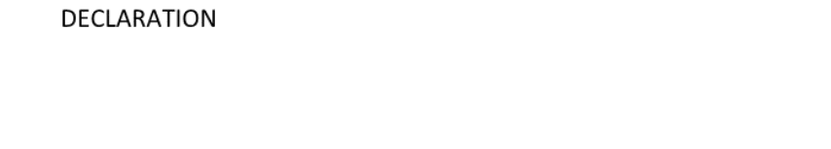

I hereby declare that the above-mentioned details are true as per my belief and knowledge.

Kiran Reddy

